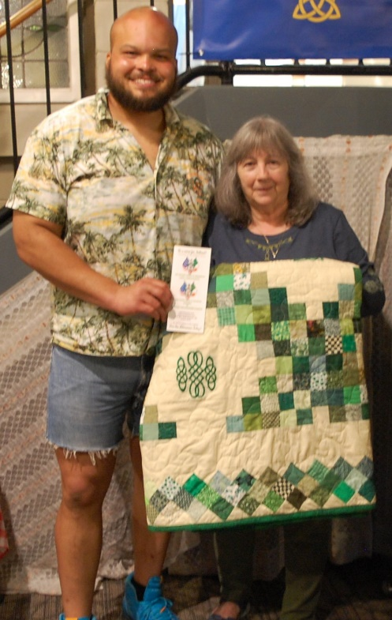

Thank you to everyone who supported the LAOH 2023 Irish Quilt raffle
The winning ticket was drawn at the Irish Cultural Center by Deirdre Reilly.
The winner is Leon Moultrie, a Rugby Player at the ICC.
Proceeds from the raffle go towards scholarships for members of the
Ladies Ancient Order of Hibernians, and the Ancient Order of Hibernians,
their children, and grandchildren;
in the name of the Maurice Donahue Scholarship Fund.
Paula Paoli – Quilt Fundraiser Chair
Pres., LAOH, Holyoke, MA, Past LAOH MA State Pres.

